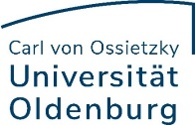

Supervision agreement according to Annex 5 to Section 5 Paragraph 1 of the Doctoral Regulations of Faculty I

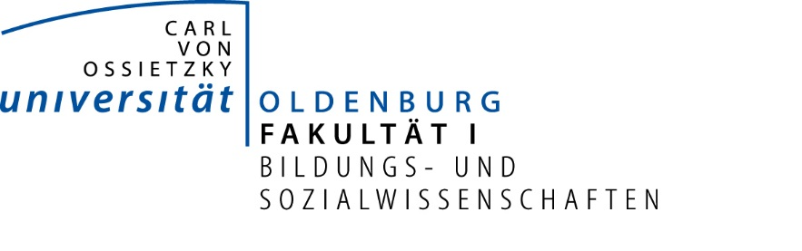
Supervision Agreement

The doctoral candidate and the following professor have agreed to conclude a Supervision Agreement for the PhD project, which is intended to guarantee the scholarly support needed for the success of the project:

Ms/Mr [doctoral candidate]

and

Ms/Mr [First supervisor]

1. School:
Doctoral subject/area:
If applicable, name of PhD programme or Graduate School:

2. Intended thesis topic (working title):

Start of the PhD project (month/year):

3. At the beginning, the doctoral candidate will draw up a timeline for the project, which is to be regularly updated and discussed with the supervisor. The doctoral candidate will report regularly, but at least once a year, to the supervisor on the preparation, development and implementation of the PhD project (progress report) and present preliminary work or parts of the thesis in the following colloquia or in comparable places.

4. Academic supervision takes place in particular through regular one-on-one discussions as well as through regular participation in events organised as part of PhD programmes and/or in School and subject-related doctoral colloquia. The first supervisor will monitor the quality of the doctoral thesis and support the independent scientific development of the doctoral candidate by providing advice and practical support. To the extent required, they will comment orally or in writing on the contributions delivered during the agreed meetings.

5. The doctoral candidate must notify the first supervisor of changes to the topic of the doctoral thesis and any changes of address.

6. All scientific activity is based on the principles of good academic practice as formulated in the guidelines of the German Research Foundation (DFG) and the corresponding regulations of the University of Oldenburg. The doctoral candidate’s first supervisor is available to answer any questions about this. The doctoral candidate will comply with these regulations.

7. If the supervisory relationship is dissolved for reasons beyond the responsibility of the doctoral candidate, the School will strive to provide an alternative suitable supervisor.

8. Utilization of scientific results in the context of dissertations: The property rights to scientific findings and results obtained in the context of research projects carried out by the University of Oldenburg belong to the university. It is agreed that these findings and results can be used in the context of the dissertation, provided that the doctoral candidate has a significant share in the development of these findings and results. This applies in particular in the case of competing publication interests of other project participants.

(Place, Date) doctoral candidate

(Place, Date) First supervisor

Seen by:
(Place, Date Chair of the Doctorate Committee of School I
Seen by:
(Place, Date) Deputy Chair of the Doctorate Committee of School I

Please note: This is an unofficial translation provided for your convenience only and does not have any legal binding effects! Only the German version is legally binding!

