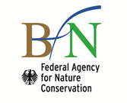

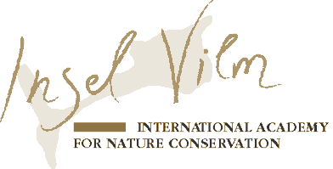
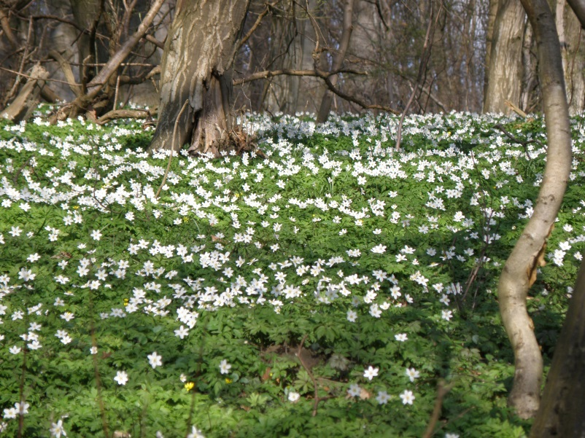
© Dr. Horst Korn

Preliminary Program

Meeting of the European Competent National Authorities implementing the Nagoya Protocol and the corresponding EU Regulation

Isle of Vilm, Germany

April 23 - 26, 2018

After entry into force of the Nagoya Protocol and the corresponding Regulation (EU) No. 511/2014 the European member states are now obligated to take steps towards their operationalization. In several EU member states “Competent National Authorities” (CNA) are in the course of formation. To foster this process and to be mutually supportive among the member states there is a great demand to exchange information on ongoing technical and structural processes as well as early implementation experiences.

Following the successful meeting of European CNAs last year in Germany on the island of Vilm, the Nagoya CNA–Unit of the German Federal Agency for Nature Conservation (BfN) will organize once more a platform for exchange in 2018.

The upcoming informal meeting will complement the half-day meetings of EU CNAs occasionally taking place before EU ABS Expert Group meetings in Brussels. It will provide an ideal opportunity to identify, present and discuss challenges as well as possible solutions on all relevant topics related to the implementation of Regulation (EU) No. 511/2014, in particular on first registration processes of collections, experiences in user controls and checkpoint communiqués as well as on any best-practice-procedures, tools or mechanisms for exercising due diligence.

The output of the meeting will be a report containing abstracts of contributions of the experts as well as workshop proceedings including the collected views on different subjects to support the future work of the EU CNAs.

Monday, 23.04.2018

Arrival of the participants at the island of Vilm

18.30 Dinner

20.30 Welcome and brief introduction to the meeting
21.00 Informal get-together

Tuesday, 24.04.2018
08.00 Breakfast

09.00 Implementation of Regulation (EU) No. 511/2014: Status quo and current challenges
- Alicja Kozlowska (EU Commission) N.N.

09.30 Control approaches and processes, first inspections
      - Contributions by EU member states

12.30 Lunch

13.30 Control challenges & possible solutions

15.00 Coffee/tea & cake

15.30 Break-out sessions

17.00 Reflection on first day

18.30 Dinner
20.00 Informal gathering

Wednesday, 25.04.2018
08.00 Breakfast

09.00 Registration of collections – country experiences
- Germany: First application for registration by German Collection of Microorganisms and Cell Cultures (DSMZ)
- Other EU member states

11.30 Legal implications of Article 4 (5) and (7) of Regulation (EU) No. 511/2014 on the liability of registered collections
      - Prof. Dr. Christine Godt, University of Oldenburg

12.30 Lunch

13.30 Best practice procedures, tools or mechanisms for exercising due diligence

15.00 Coffee/tea

15.15 Awareness-raising and capacity-building: Measures to inform/involve user sectors in member states

17.00 Way forward & end of meeting

17.30 Reception at the invitation of the German Federal Agency for Nature Conservation (BfN)
21.00 Informal gathering and farewell

Thursday, 26.04.2018

07.00 Early-bird breakfast

07:30-09:00 Breakfast
07.25 First boat from the Isle of Vilm, arrival in Lauterbach at 7.35
08.25 Boat from the Isle of Vilm, arrival in Lauterbach 8.35

Train connection from Lauterbach/Mole at 8.00/9.00, arrival in Bergen auf Rügen at 8.20/ 9.20, direct train from Bergen auf Rügen at 9.27 to Berlin Central Station, arrival at 13.16

09.20 Boat from the Isle of Vilm, arrival in Lauterbach at 9.30

Train connection from Lauterbach/Mole at 10.00, arrival in Bergen auf Rügen at 10.20,
direct train from Bergen auf Rügen at 10.55 to Berlin Central Station, arrival at 15.16
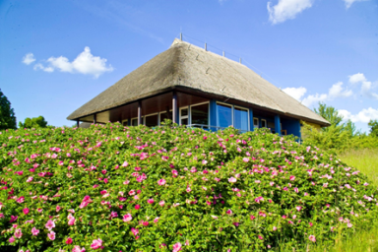

The Isle of Vilm, 94 hectares in area, is a beautiful nature paradise, a Baltic Sea coast treasure. The island's natural beauty has long fascinated people. The first steps to protect its ancient forest from logging were taken back in 1812. In 1936, the Isle of Vilm was set aside as a nature reserve. Since 1990, it has been one of the core areas of the Southeast-Rügen Biosphere Reserve.

