WEBINAR
Comparative Corona Contract Law
A first academic look at the impact of COVID-19 on contract law across Europe
Date: 22 May 2020
Time: 10 AM Central European Summer Time, 9 AM British Summer Time

10.00-10.10 Opening, greetings (and coffee from your own kitchen)
Karin Sein, Hugh Beale
I session
10.10- 10.30 United Kingdom
Hugh Beale and Christian Twigg-Flesner (University of Warwick)
10.30-10.50 Germany
Peter Rott (University of Oldenburg)
10.50-11.10 Spain
Beatriz Gregoraci (Autonomous University of Madrid)
11.10-12.00 Discussion
Lunch/coffee break 12.00-12.40
II session
12.40-13.00 Poland
Aneta Wiewiórowska-Domagalska (University of Osnabrück)
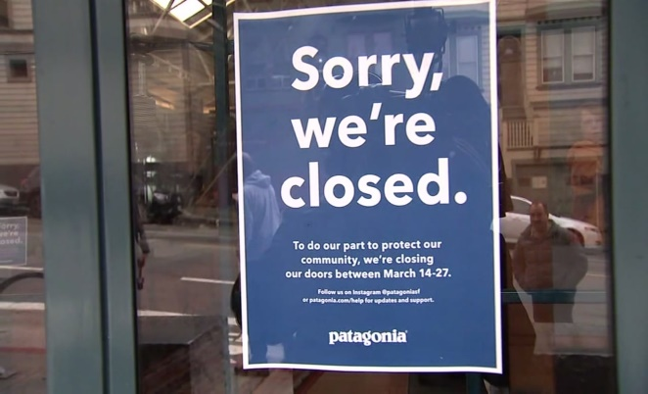
13.00-13.20 Sweden
Christina Ramberg (University of Stockholm)
13.20-13.40 Estonia
Karin Sein (University of Tartu)
13.40-14.20 Discussion
14.20-14.30 Conclusions
Hugh Beale and Karin Sein
For participation please register here
Participants will receive a Zoom link to watch the webinar. In case you have questions, please contact Triin Metsallik (triin.metsallik@ut.ee)

