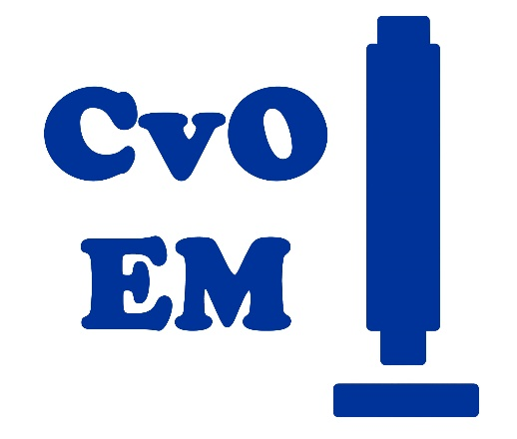
Training request form

Your name

Your email address

Department, working group, room #, phone #

Supervisor name

On which instrument do you require an introduction/assistance? If not sure, give detailed job description below, so we can decide which technique will be the best
( ) HR-TEM JEOL 2100F with EDX
( ) TEM Zeiss 900N
( ) SEM JEOL IT800 with EDX
( ) Epi Fluorescence microscope Zeiss Axioskop 2

Your microscopy experience: list techniques you have already applied, instruments you worked with, and attended courses

Write here a clear job description, what do you want to image

What type of samples are you using for your experiment?

How do you prepare your samples?

How often do you plan to use the facility?

How will you process your data? Image analysis plan

Materials to read before:
For TEM https://myscope.training/#/TEM
For SEM https://myscope.training/#/SEMlevel_3_1
General microscopy https://myscope.training/

