Dr. Jörn Anemüller |  | AG Medical Physics Department für medizinische Physik und Akustik , Fakultät VI | Statistical signal models, Signal processing, Machine learning, Computational neuroscience | Signal processing, acoustics, statistics and machine learning, data analysis | BM: neu250  RM: neu510
Apl. Prof. Dr. Karin Dedek | 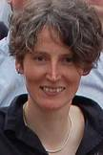 | AG Animal Navigation, Institut für Biologie und Umweltwissenschaften, Fakultät V | Localization and function of gap junctions in the mouse retina, Functional role of retinal interneurons | Retina, electrophysiology, patch-clamp, quantitative immunohistochemmistry, STED/confocal microscopy | BM: neu140, neu150  RM: neu440
Dr. Carsten Gießing |  | AG Cognitive Neurobiology, Department für Psychologie, Fakultät VI | Cognitive neuroscience, Functional neuroimaging, Complex networks |  | BM: neu220, neu270
Prof. Dr. Martin Greschner | 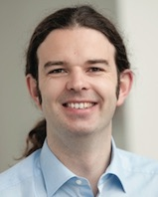 | AG Visual Neuroscience, Department für Neurowissenschaften, Fakultät VI | Retina, Visual system, Elektrophysiology, Multi-elektrode-array, Visual coding |  | BM: neu240, neu140  RM: neu440, neu510
Dr. Anna-Maria Hartmann | 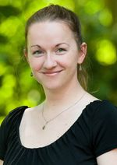 | AG Neurogenetics, Department für Neurowissenschaften, Fakultät VI | Cation-Chloride Co-transporter, KCC2, Evolution, Analysis of structure-function relation-ships | Molecular Biology (cloning, SDM), Biochemistry (protein purification, flux measurements), Evolutionary Biology (alignment, phylogenetic trees)
Prof. Dr. Jannis Hildebrandt | 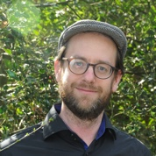 | AG Auditory Neuroscience, Department für Neurowissenschaften, Fakultät VI | Auditory Neuroscience, Systems Neuroscience, Behavioral Physiology | optogenetics, electrophysiology,  data Analyis, animal behavior, histology | BM: neu240  RM: neu410, neu510  SM: neu710, neu760
Apl. Prof. Dr. Ulrike Janssen-Bienhold | 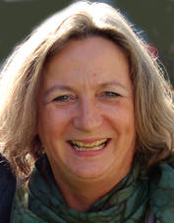 | AG Neurobiology, Department für Neurowissenschaften, Fakultät VI | Molecular and cellular neuroscience, Neuroanatomy, Signal transduction in the nervous system, Vision research |  | BM: neu150  RM: neu440
Prof. Dr. Georg Klump | 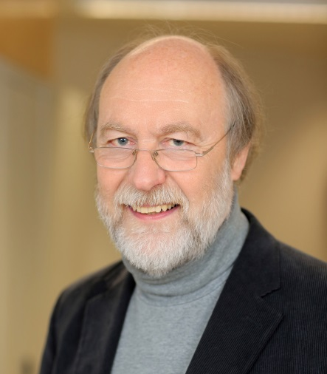 | AG Animal Physiology and Behaviour, Department für Neurowissenschaften, Fakultät VI | Behavioural Physiology,  Systems Neuroscience,  Animal Psychoacoustics,  Neuronal processing in the auditory pathway,  Communication |  | BM: neu210, neu270  RM: neu410, neu540  SM: neu750
Prof. Dr. Karl-Wilhelm Koch | 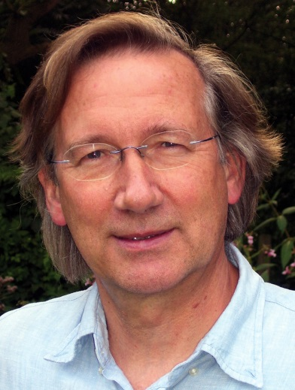 | AG Biochemistry, Department für Neurowissenschaften, Fakultät VI | Retinal phototransduction, Calcium-sensing proteins, Guanylate cyclases, Molecular basis of congenital retinal degeneration, Receptors and signal transduction | cloning procedures, site-directed mutagenesis, protein expression and purification,  functional characterization of proteins in a cellular context, protein-protein interaction | BM: neu170, neu190  RM: neu470
Prof. Dr. Christine Köppl | 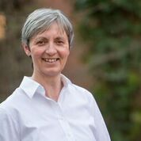 | AG Cochlea and Auditory Brainstem Physiology, Department Neurowissenschaften, Fakultät VI | Physiology, anatomy and evolution of hearing |  | BM: neu110, neu120  RM: neu410, neu570  SM: neu730, neu750
Prof. Dr. Jutta Kretzberg | 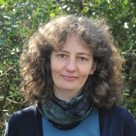 | AG Computational Neuroscience, Department Neurowissenschaften, Fakultät VI | Computational Neuroscience, Sensory physiology, Neuronal coding, Invertebrate Neuroscience | Modeling, Statistical Data Analysis, Intracellular Electrophysiology, Voltage Sensitive Dyes | BM: neu240, neu250, neu140  RM: neu540, neu510
Dr. Ulrike Langemann | 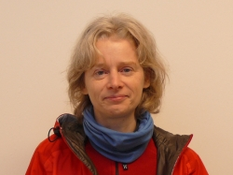 | AG Animal Physiology and Behaviour, Department für Neurowissenschaften, Fakultät VI | Zoology, Sensory physiology |  | BM: neu210, neu270  SM: neu750
Prof. Dr. Hubert Löwenheim | 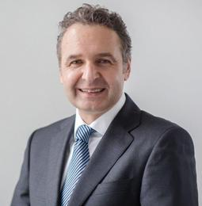 | Universitätsklinik Hals-Nasen-Ohrenheilkunde am Evangelischen Krankenhaus Fakultät VI | Auditory research, Regenerative medicine, Individualized medincine, Cochlear implants |  | RM: neu570
Prof. Dr. Henrik Mouritsen | 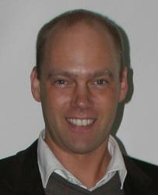 | AG Animal Navigation, Institut für Biologie und Umweltwissenschaften, Fakultät V | Animal navigation, Magnetoreception |  | BM: neu210  RM: neu540
Dr. Marcus Müller | 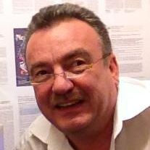 | Universitätsklinik Hals-Nasen-Ohrenheilkunde am Evangelischen Krankenhaus Fakultät VI | Auditory research, Electrocochleography, Cochlear anatomy, Regenerative medicine |  | RM: neu570
Prof. Dr. John Neidhardt | 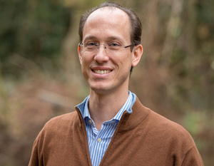 | AG Human Genetics, Department für Humanmedizin, Fakultät VI | Human genetics, Therapy development, Eye diseases, Retinal degeneration, Hearing impairment |  | BM: neu170  RM: neu470
Prof. Dr. Hans Gerd Nothwang | 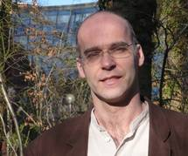 | AG Neurogenetics, Department für Neurowissenschaften, Fakultät VI | (Epi-)genetics, Developmental biology, Evo-devo, Deafness, Auditory system |  | BM: neu110, neu120, neu170  RM: neu470, neu570
Prof. Dr. Jochem Rieger | 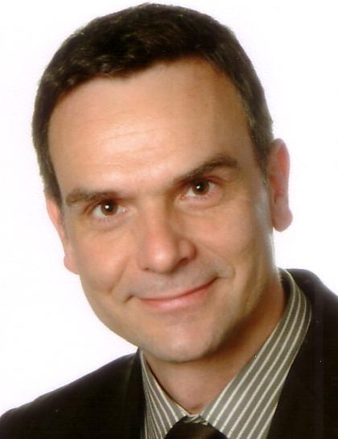 | AG Applied Neurocognitive Psychology, Department für Psychologie, Fakultät VI | Human neurophysiology of perception and action, Brain machine interfaces, Statistical learning in neurophysiology, fMRI, MEG/EEG, Electrocorticography |  | BM: neu250  RM: neu510
Dr. Alexander Scholten |  | AG Biochemistry, Department für Neurowissenschaften, Fakultät VI | Phototransduction in the retina, Neuronal calcium sensor proteins, Guanylate cyclases, Molecular basics of inherited neurodegenerations in the retina |  | BM: neu190
Dr. Ulrike Sienknecht | 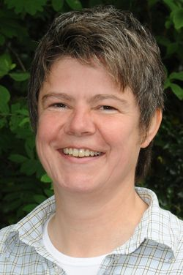 | AG Cochlea and Auditory Brainstem Physiology, Department Neurowissenschaften, Fakultät VI | Developmental Biology, Evolution, Vertebrates, Auditory System |  | BM: neu110, neu120  RM: neu570  SM: neu730
Dr. Fabian Sobotka | 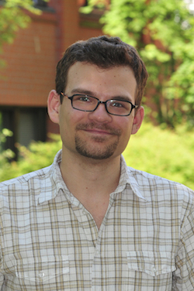 | Health Services Research, Fakultät VI | Quantile regression, Expectile regression, Geostatistics, Semiparametric regression, Boosting | Semiparametric Regression  Expectile and Quantile Regression  GAMLSS  Boosting  Spatial Statistics  Instrumental Variables  Graphical Models | SM: neu770, neu720
Prof. Dr. Kathrin Thediek |  | AG Metabolic Signaling, European Medical School (EMS) - Universität Groningen (NL) und Universität Oldenburg,(D) | Metabolic signaling, Mammalian Target of Rapamycin (mTOR), Cell growth and ageing, Protein homeostasis |  | BM: neu170  RM: neu470  SM: neu740
Prof. Dr. Christiane Thiel |  | AG Biological Psychology, Department für Psychologie, Fakultät VI | Cognitive neuroscience, Functional neuroimaging, Psychopharmacology | fMRI, behavioural experiments, pharmacological interventions | BM: neu220, neu270

