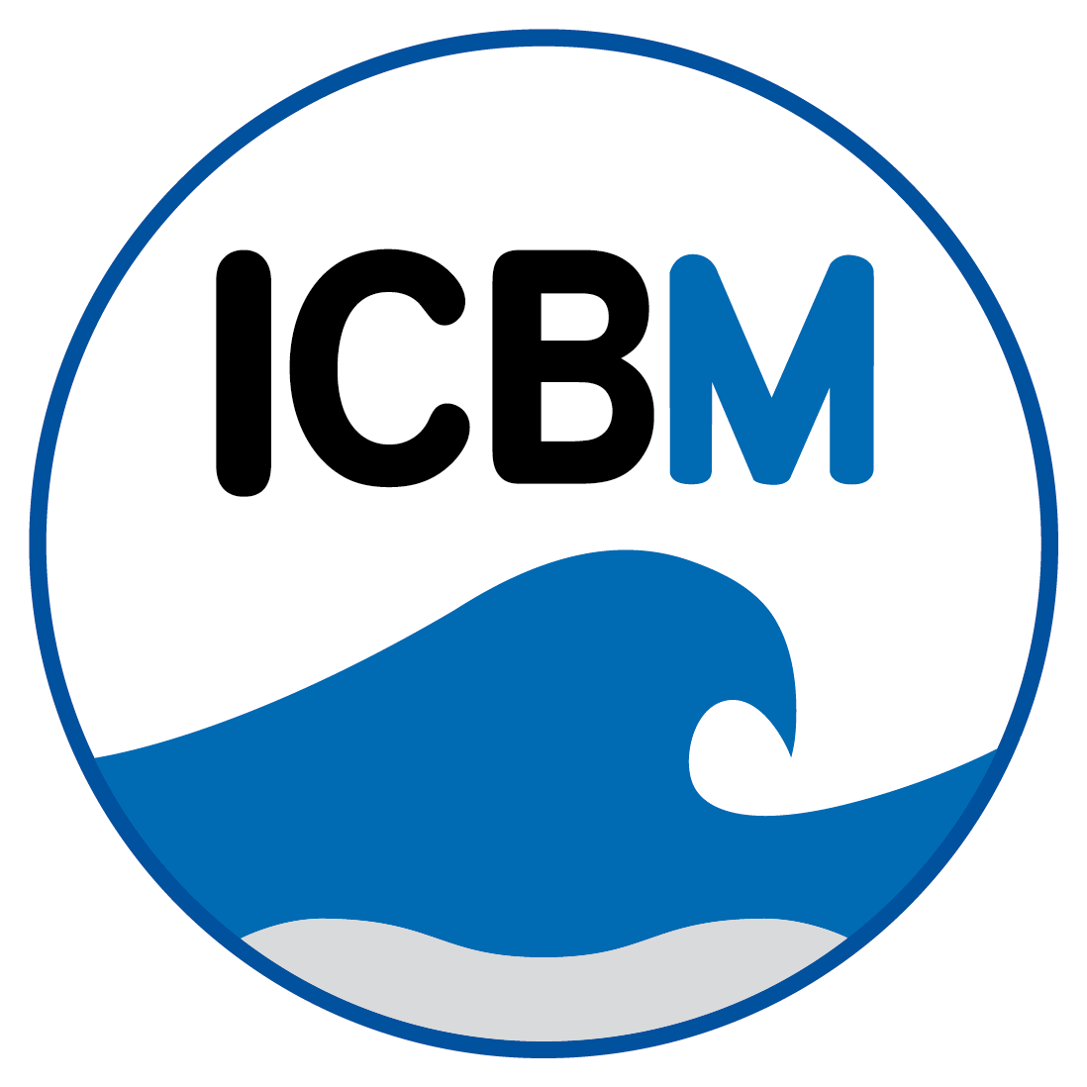

**Geochemisches Seminar ICBM WiSe 2015/2016**

Dienstags 16:15-17:45 Uhr, Seminarraum W15-1-146

**27.10.2015**

Helena Osterholz (Marine Geochemistry)

*“Seasonal and interannual variability of the dissolved organic matter composition in the Delaware estuary”*

**10.11.2015**

Martin Krull (Microbiogeochemistry)

*“Die Quantifizierung von gelöstem Mn(III) und Mn(II) im Porenwasser von Strandsedimenten”*

Mariana Ribas Ribas (Sea Surfaces)

*“Introduction to the SOPRAN Seawater AEOLOTRON experiment in Heidelberg”*

**24.11.2015**

Janis Ahrens (Microbiogeochemistry)

*“Reaktives Eisen in Spiekerooger Strandsedimenten: Sequentielle Extraktion von Fe-Mineralphasen”*

Anika Pohlabeln (Marine Geochemistry)

*“Evidence for abiotic sulfurization of marine organic matter in sulfidic environments”*

**08.12.2015**

Lukas Belz (Organic Geochemistry)

*“Paleoenvironmental reconstruction based on biomarkers and stable isotopes in Kalahari salt pan sediments”*

Hongyan Bao (Hanse Fellow, Marine Geochemistry)

*“tba”*

**12.01.2016**

Melanie Behrens (Marine Isotope Geochemistry)

*“Trace element inputs to the West Pacific from Nd isotopes and rare earth elements”*

Beatriz Noriega Ortega (Marine Geochemistry)

*“Is the molecular diversity of marine dissolved organic matter already imprinted in the exometabolome of single bacterial strains?”*

Gudrun Massmann

*“Projekt zur Genese der Süßwasservorkommen unterhalb der Ostplate Spiekeroogs - kurze Vorstellung und Diskussion möglicher Kooperationen”*

**26.01.2016**

Torben Struve (Marine Isotope Geochemistry)

*“tba”*

Hannelore Waska (Marine Geochemistry)

*“Trace metal-DOM interactions in Spiekeroog subterranean estuaries”*