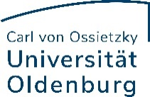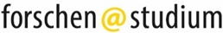

Application Form
Student Research Project Funding – Topic: Future
- Information about the research project
Project title
Duration of the project
(between and no longer than March - Nov 2021)

- Applicant(s) Information
 | First and last name | Degree program / school | Email
1

2

3

4

- Supervisor
First and last name
Institute and school
Email, phone

- Cost Calculation
For the cost calculation, please use the following fully-burdened wage: €13,50 for students without a degree and €15,76 for students with a bachelor's degree. The maximum funding for each project is €5.000.
- Researchers
First and last name | Number of hours per month | Hourly rate | Number of months | Amount
Total Personnel

- Equipment / Material Costs
Purpose | Amount
Total Material Costs

- Total for the Entire Project
Project Total

- Additional Documents
☐ Instructor’s statement (either email or letter signed by the instructor) confirming they have agreed to supervise the project and that no credits will be awarded
☐ Short description of the project (approx. one A4 page) outlining the research question and methods

Please send your complete application no later than January 25, 2021 to
forschen-at-studium@uni-oldenburg.de

